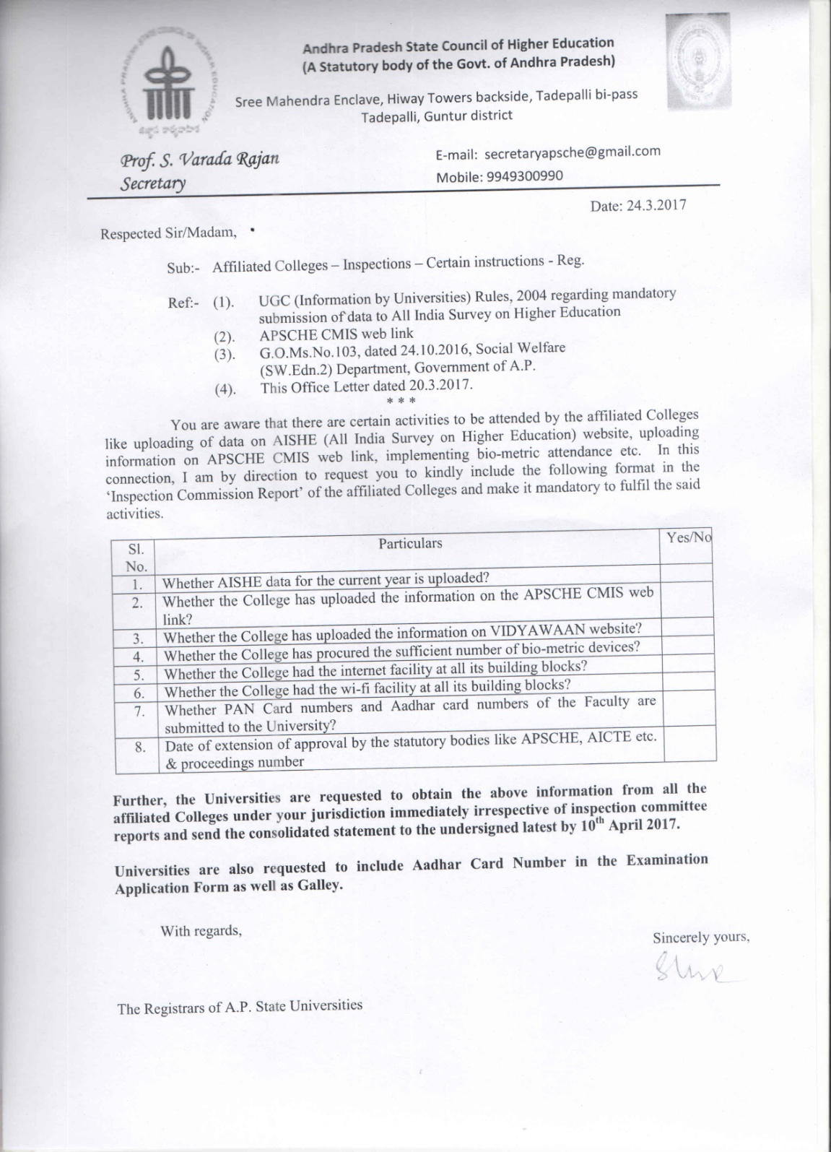
PROFORMA
S.NO | PARTICULARS | YES/NO
01 | Whether AISHE data for the current year is uploaded?
02 | Whether the college has uploaded the information on the APSCHE CMIS web link?
03 | Whether the college has uploaded the information on VIDYAWAN website?
04 | Whether the college has procured the sufficient number of bio-metric devices?
05 | Whether the college had the internet facility at all its building blocks?
06 | Whether the college had the wi-fi facility at all its building blocks?
07 | Whether PAN card numbers and Aadhar card numbers of the Faculty are submitted to the University
08 | Date of extension approval by the statutory bodies like APSCHE, AICTE etc. & proceedings number
09 | List of the faculty members and their PAN numbers.

