ANDHRA UNIVERSITY
DEPARTMENT OF PHYSICAL EDUCATION AND SPORTS SCIENCES
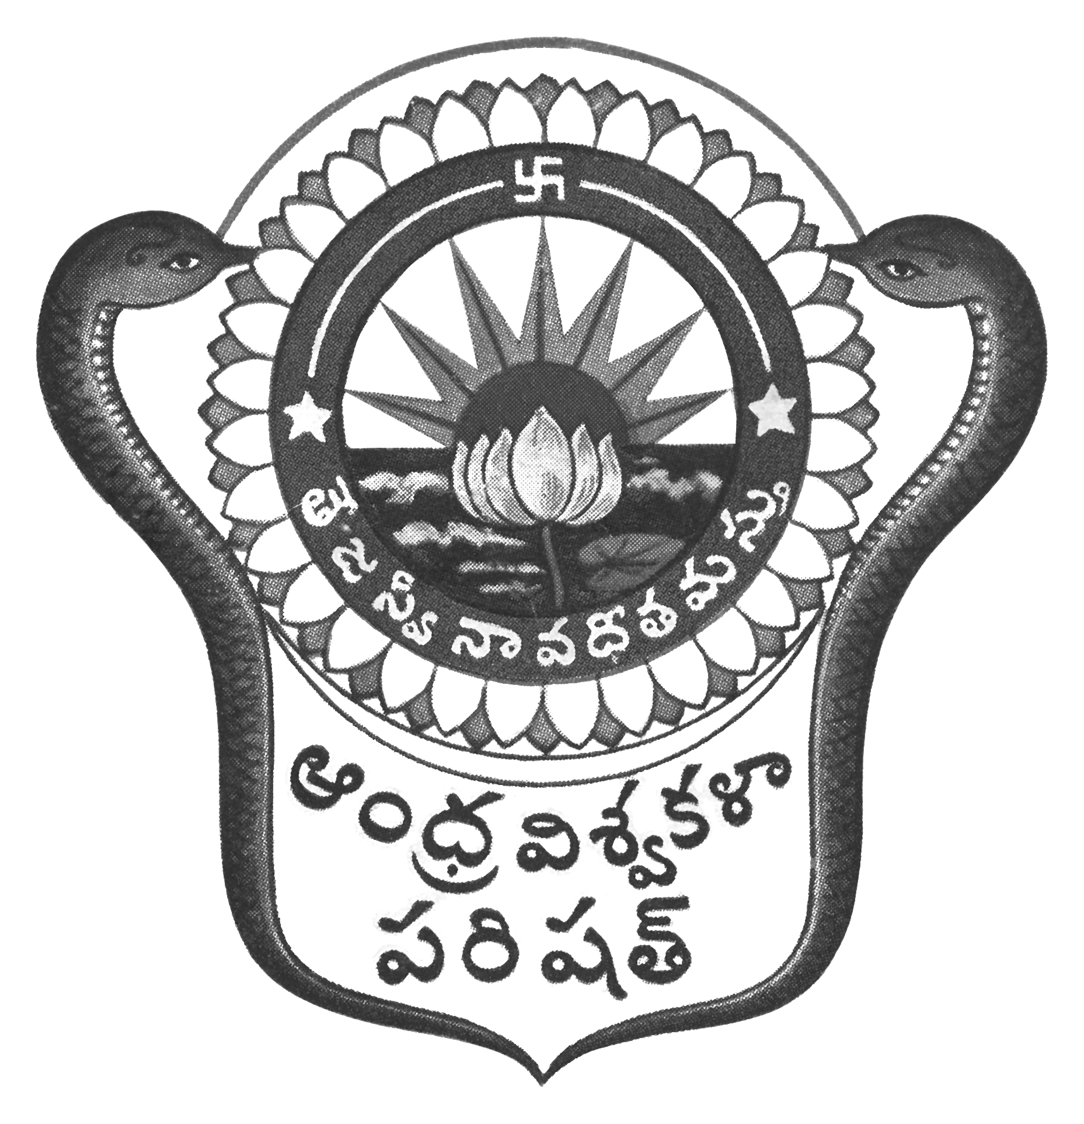
Prof.N.Vijay Mohan, M.P.Ed., DNIS., NIS., PG.DSM, Ph.D.  Director & Head  Dept. of Physical Education & Sports Sciences  Andhra University  Visakhapatnam-530 003 (AP) | 0891-2844496  Cell: 9703831117  vijaymohansports@gmail.com  ausportsvsp@gmail.com  Web: andhrauniversity.edu.in

No.AUSB/ICGS/Circular-3/2018-19 Date: 18-09-2018

To
The Principals,
Affiliated Colleges of Andhra University,

Sir,
Sub:- Andhra University Inter-Collegiate-cum-University team selections 2018-19 – Reg.
&&&
The Andhra University Inter-Collegiate-cum-University team selections to the following events will be conducted on the dates and venues noted against the events. The players may report at the venue with the necessary eligibility along with passport size photograph duly signed by the Principal (Facsimile not allowed) on the reverse side on the photograph and pinned to the eligibility Performa. Students born on or after 01-07-1993 are eligible. The players should report at 8.00 AM to the Organizing Secretary with eligibility.

S.No. | EVENT | DATE | VENUE
01. | Gymnastics (Men & Women)  University team selections | 05-10-2018 | Andhra University Campus, Visakhapatnam  Contact No. 9985399955 & 7386588712
02. | Wrestling (Men & Women)  University team selections | 06-10-2018 | Andhra University Campus, Visakhapatnam  Contact No. 9985399955 & 7386588712
03. | Football (Men)  Inter-Collegiate-cum-Univ. Selections | 08-10-2018  &  09-10-2018 | Andhra University Campus, Visakhapatnam  Contact No. 9985399955 & 7386588712
04. | Weightlifting & Best Physique (Men)  Inter-Collegiate-cum-Univ. Selections | 10-10-2018 | Dr.L.Bullayya College, Visakhapatnam  Contact No:9703677788 & 8247509541
05. | Weightlifting (Women)  Inter-Collegiate-cum-Univ. Selections | 11-10-2018 | Dr.L.Bullayya College, Visakhapatnam  Contact No:9703677788 & 8247509541
06. | Athletics (Men & Women)  Inter-Collegiate-cum-Univ. Selections | 12-10-2018  &  13-10-2018 | Andhra University Campus, Visakhapatnam  Contact No. 9985399955 & 7386588712

Thanking you, Yours sincerely,
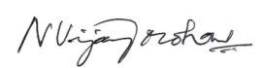
(N.VIJAY MOHAN)
DIRECTOR OF PHYSICAL EDUCATOIN
AND SECRETARY SPORTS BOARD
Copy to the Secretary to the Vice-Chancellor, AU
Copy to the P.A. to Registrar, A.U. Visakhapatnam
Copy to all the Principals of Campus Colleges,
Copy to all the Lecturers in Physical Education/Physical Directors
Copy to all the Heads of the Departments and Chief Wardens, A.U. Colleges
With a request to display on NOTICE Board.

