ANDHRA UNIVERSITY
DEPARTMENT OF PHYSICAL EDUCATION AND SPORTS SCIENCES
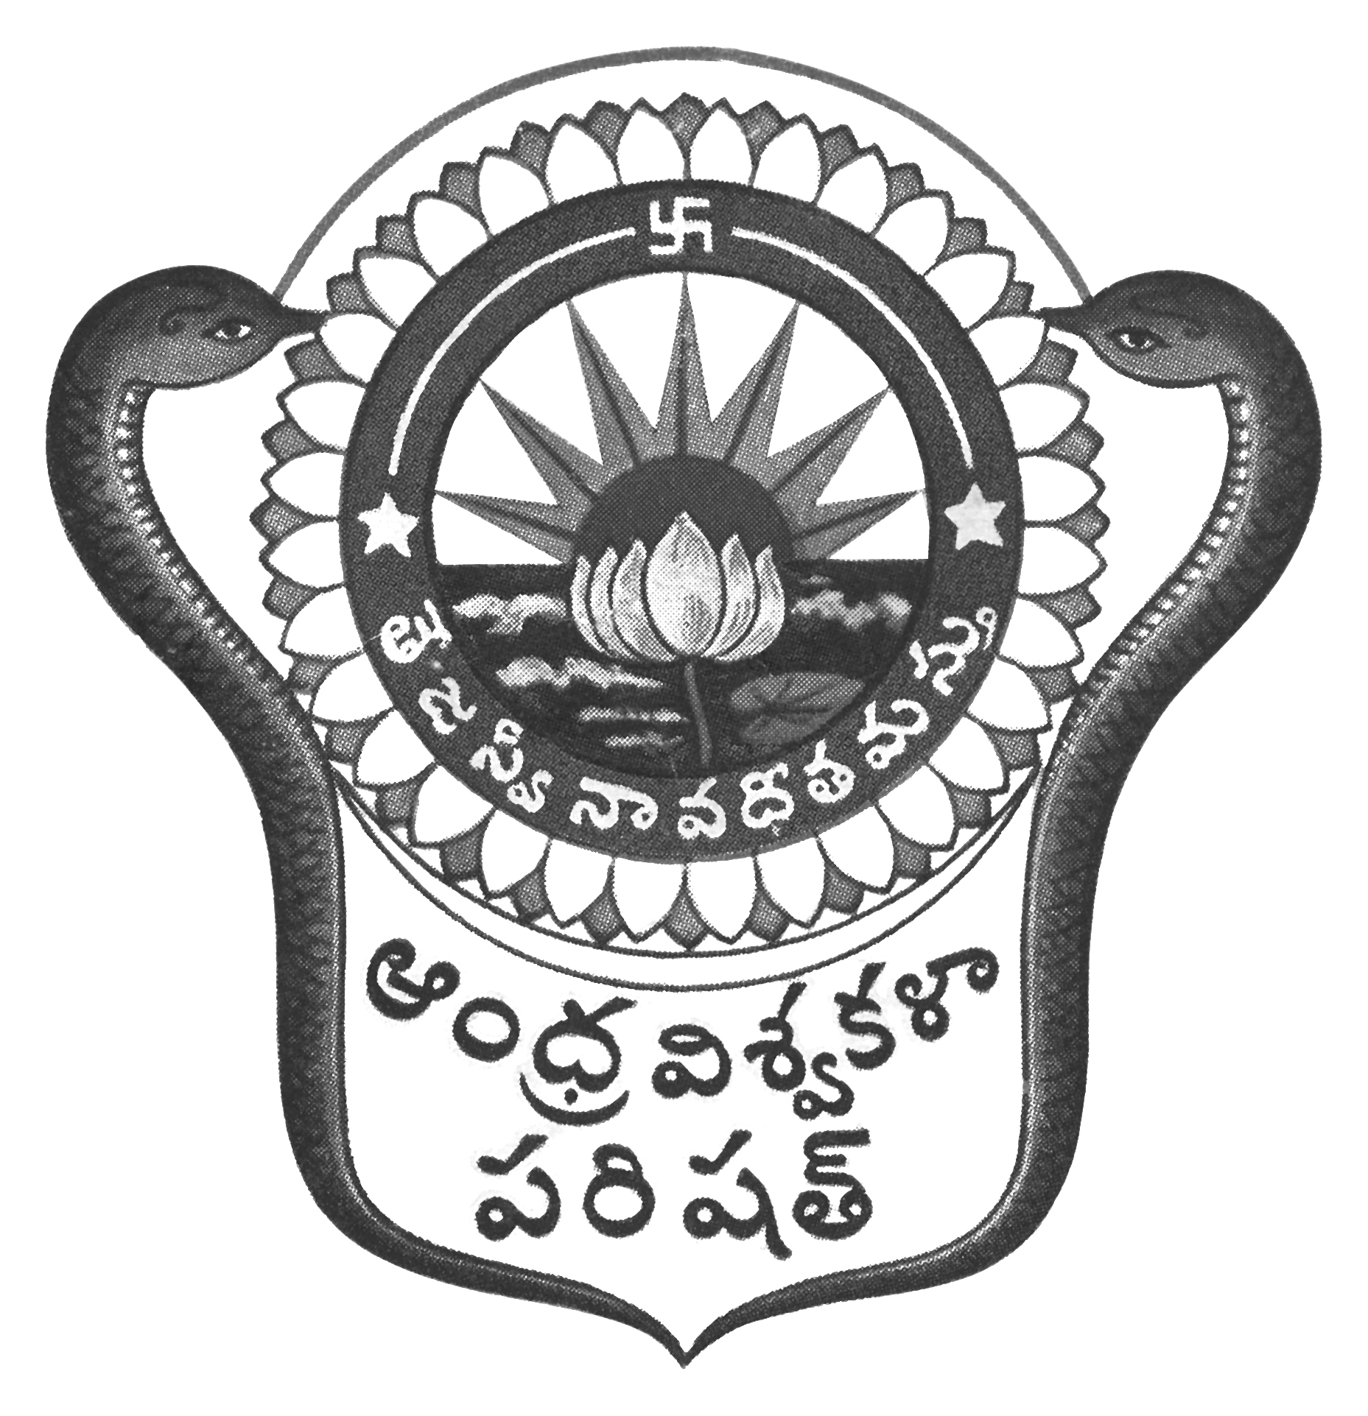
Prof.N.Vijay Mohan, M.P.Ed., DNIS., NIS., PG.DSM, Ph.D.  Director & Head  Dept. of Physical Education & Sports Sciences  Andhra University  Visakhapatnam-530 003 (AP) | 0891-2844496  Cell: 9703831117  vijaymohansports@gmail.com  ausportsvsp@gmail.com  Web: andhrauniversity.edu.in

To Date: 26.01.2019
The Principals
Affiliated Colleges of Andhra University

Sir/Madam,

KIND ATTENTION
The Andhra University Inter-University Kick Boxing (Men & Women) team selections scheduled on 5th February, 2019 at AU Golden Jubilee Grounds, Visakhapatnam is postponed to 8th February, 2019 at Boxing Academy, Visakhapatnam Port Stadium.
Thanking you,
Yours sincerely,
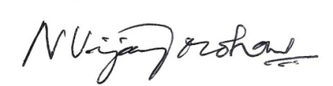
(N.VIJAY MOHAN)

Copy to all the Principals of Campus Colleges,
Copy to all the Lecturers in Physical Education/Physical Directors

