ANDHRA UNIVERSITY
DEPARTMENT OF PHYSICAL EDUCATION AND SPORTS SCIENCES
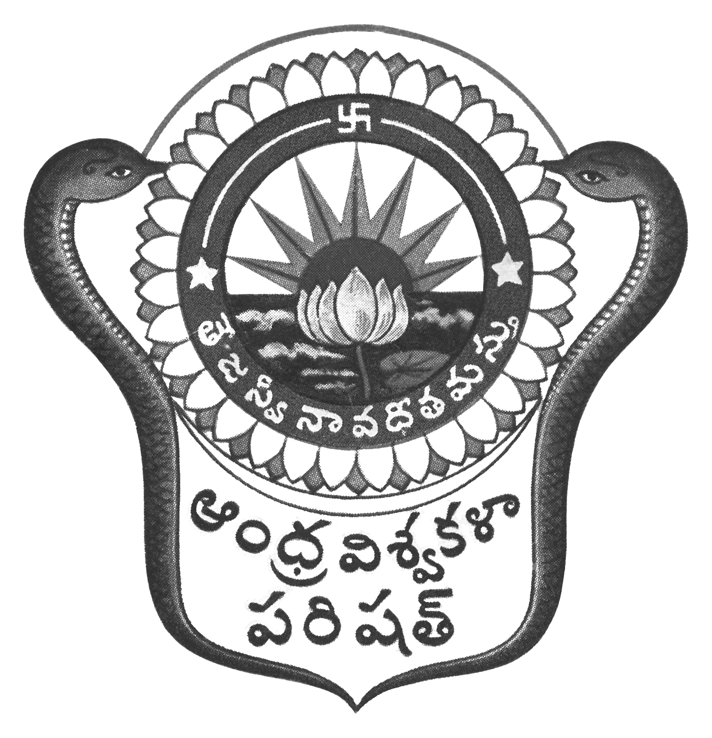
Prof.N.Vijay Mohan, M.P.Ed., DNIS., NIS., PG.DSM, Ph.D.  Director & Head  Dept. of Physical Education & Sports Sciences  Andhra University  Visakhapatnam-530 003 (AP) | 0891-2844496  Cell: 9703831117  vijaymohansports@gmail.com  ausportsvsp@gmail.com  Web: andhrauniversity.edu.in

No.AUSB/Summer Coaching Camp/2018 Date: 23-04-2018

To
The Principals
AU Campus & Affiliated Colleges of Andhra University

Sir,

Sub: - Andhra University Volleyball (Men) Summer Coaching Camp – Reg.
&&&
Andhra University Sports Board with an intention to build up formidable Volleyball (Men) teams for 2018-19 Inter-University Tournaments, would like to conduct Volleyball (Men) summer coaching camp from 07.05.2018 to 31.05.2018 at AU Silver Jubilee Grounds for Andhra University Campus and affiliated colleges students. Students who participated in the AU Inter-Collegiate Tournaments can avail this opportunity.

Sri D.Sivaji Raju, former national player has consented to impart coaching and training.

For outstation students accommodation will be provided.

Students: Report on or before 7th May, 2018 to Sri D.Sivaji Raju (9000245558) Dr.G.S.Varma, Camp Coordinator (Cell no 9985399955).

Thanking you,
Yours sincerely,
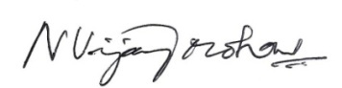
(N.VIJAY MOHAN)

Copy to the Secretary to the Vice-Chancellor, AU
Copy to the P.A. to Registrar, A.U. Visakhapatnam
Copy to all the Principals of Campus Colleges,
Copy to all the Lecturers in Physical Education/Physical Directors

