ANDHRA UNIVERSITY
DEPARTMENT OF PHYSICAL EDUCATION AND SPORTS SCIENCES
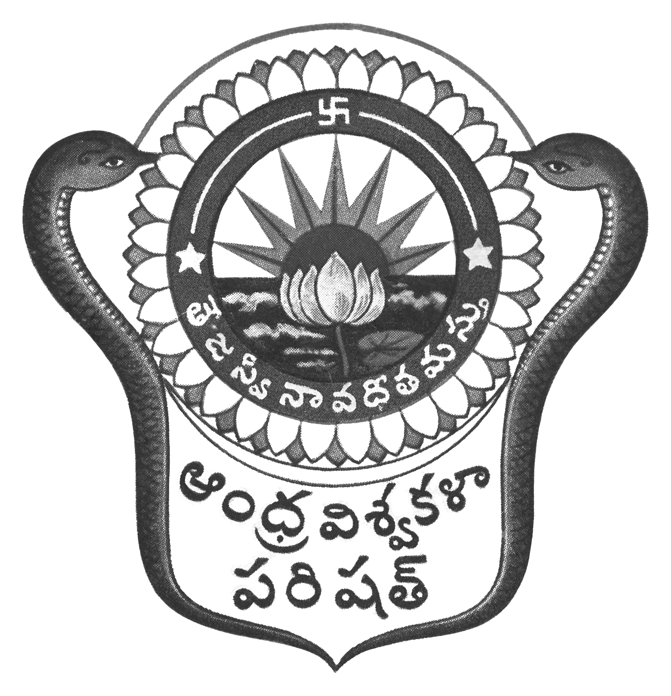
Prof.N.Vijay Mohan, M.P.Ed., DNIS., NIS., PG.DSM, Ph.D.  Director & Head  Dept. of Physical Education & Sports Sciences  Andhra University  Visakhapatnam-530 003 (AP) | 0891-2844496  Cell: 9703831117  vijaymohansports@gmail.com  ausportsvsp@gmail.com  Web: andhrauniversity.edu.in

No.AUSB/ICGS/Circular-10/(Revised)/2018-19 Date: 21-12-2018

To
The Principals,
Affiliated Colleges of Andhra University,

Sir,
Sub:- AU - University Cricket (Men) team selections 2018-19 – Reg.

&&&

The Andhra University Cricket (Men) team selections will be held on 27th December, 2018 at Raghu College of Pharmacy, Dakamarri, Visakhapatnam. Report at the venue at 8.00 AM with the necessary eligibility along with passport size photograph duly signed by the Principal (Facsimile not allowed) on the reverse side on the photograph and pinned to the eligibility Performa. Students above 17 years and below 25 years by 01-07-2018 are only eligible. .
Contact: 9440649945

Thanking you, Yours sincerely,
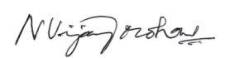
(N.VIJAY MOHAN)
DIRECTOR OF PHYSICAL EDUCATOIN
AND SECRETARY SPORTS BOARD
Copy to the Secretary to the Vice-Chancellor, AU
Copy to the P.A. to Registrar, A.U. Visakhapatnam
Copy to all the Principals of Campus Colleges,
Copy to all the Lecturers in Physical Education/Physical Directors
Copy to all the Heads of the Departments and Chief Wardens, A.U. Colleges
With a request to display on NOTICE Board.

