Syllabus
TELUGU
(UG Courses)
Admitted Batch 2008 -2009



May 2008
A.P. State Council of Higher Education

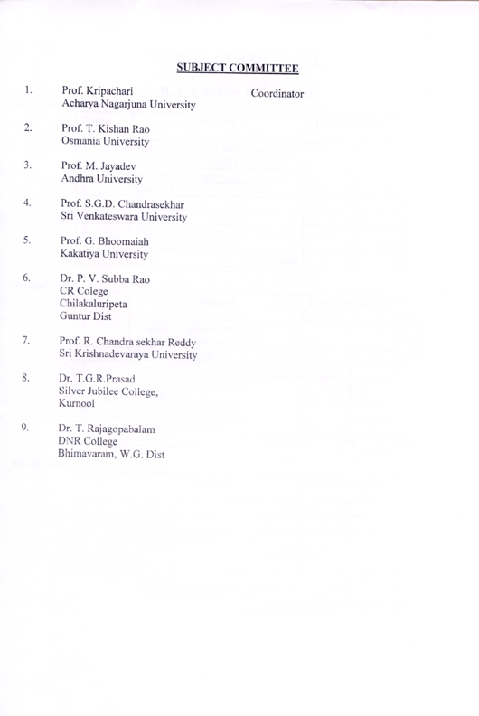
B.A. Course (Structure)

First year:

S.No. | Subject | Hrs per Week
1. | English language including communication skills | 6
2. | Second language | 4
3. | Core l-1 | 6
4. | Core 2-1 | 6
5. | Core 3-1 | 6
6. | Foundation course | 3
7. | Computer Skills | 2
 | Total | 33

Second year:

S.No. | Subject | Hrs per week
1. | English language including communication skills | 6
2. | Second language | 4
3. | Core 1-II | 6
4. | Core 2-II | 6
5. | Core 3-II | 6
6. | Environmental studies | 4
7. | Computer skills | 2
 | Total | 34

Third year:

S.No. | Subject | Hrs per week
1. | Core 1-III | 5
2. | Core 1 – IV | 5
3. | Core 2 – III | 5
4. | Core 2 – IV | 5
5. | Core 3-III | 5
6. | Core 3 – IV | 5
7. | Foundation course | 3
 | Total | 33



