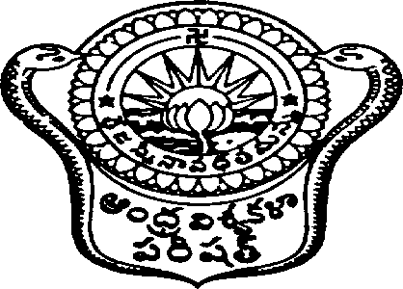
Andhra University
Application for Issue of Original Degree In-Advance to the Convocation
( M.Phil., / Ph.D. )

01. | Name in Full (in Capitals) |  |  | :
02. | Sex |  |  | : | Male | Female
03. | Pass Particulars |  |  | :
 | a. | Register Number |  | :
 | b. | Year of Passing |  | :
 | c. | Class Obtained |  | :
 | d. | Branch |  | :
 | e. | Applied to any Convocation or not |  | :
 | f. | College which studied |  | :
 | g. | Date of Examination attended by him/her to qualify for Degree |  | :
04. | Reasons for taking the Degree In-Advance |  |  | :
05. | Address to which the Diploma should be Dispatched |  |  | :
 | Contact Phone Number |  |  | :
06. | Particulars of the fee paid |  | D.D.No. | :
 |  |  | Date | :
 |  |  | Amount | :
 |  |  | Name of the Bank | :

Signature of the Candidate

Note:
 | 01. | The Candidate should fill all the Coolum’s without fail. He/She should enclose Original Degree of the Lower Examination (or) Attested Xerox Copy of the same.
 | 02. | for M.Phil.,/Ph.D. Duplicate Degree Certificate, the Candidate should submit a Certificate from Public Notary and Police Complaint together with D.D. in favour of Registrar, Andhra University, Visakhapatnam.

